VIA USB 2.0 Host Controller
Driver Installation Guide
(Revision 2.0)
10/30/02
Contents
1.0 System Requirement………………………………………...P.3
2.0 Driver Limitations…………………………………………...P.3
3.0 Driver Installation for Windows XP ……………………….P.4
4.0 Driver Installation for Windows 2000……………………...P.7
5.0 Driver Installation for Windows ME/98SE/98……............P.13

1.0 System Requirement
This setup program will install the driver for VIA USB 2.0 Host Controller. Before you start to run the setup program, please make sure your computer is an IBM PC-compatible system.

This driver can be used either the following operating systems:
- Windows98
- Windows98 Second Edition.
- Windows Millennium.
- Windows 2000.
- Windows XP.

2.0 Driver Limitations
Known driver issues and limitations are listed in ReleaseNote.txt. Please check this file for detail.

Please visit VIA web site (http://www.via.com.tw) to get the latest driver.

3.0 Driver Installation for Windows XP

- Due to legal issue, Microsoft EHCI drivers for Windows XP are not included inside this package.
SETUP.exe will redirect you to Microsoft Windows Update to download the drivers instead. Be sure you are connected to the internet.

- Select “Install USB 2.0 Host driver”

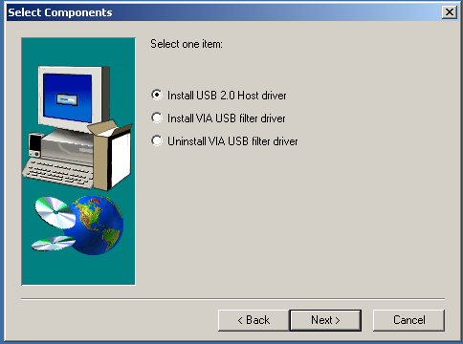

- Click “Yes” and setup program will help you to connect to the Windows Update web site.

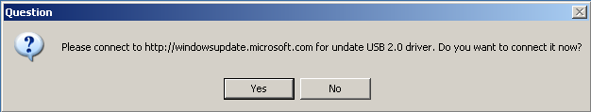

2. SETUP.exe launches Microsoft Internet Explorer and opens http://windowsupdate.microsoft.com. Click “Scan for updates” to get the latest updates if available.

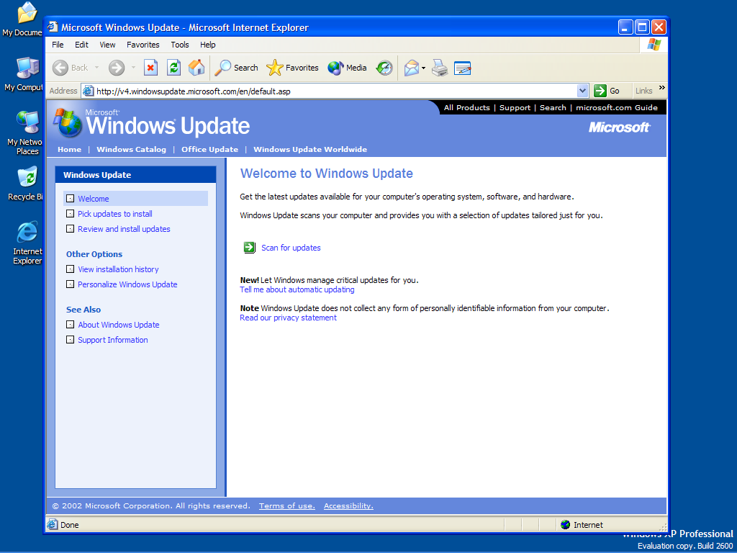

3. Microsoft Windows Update lists all available updates on the Web. We suggest you to download Windows XP Service Pack 1 because Microsoft EHCI drivers are included.

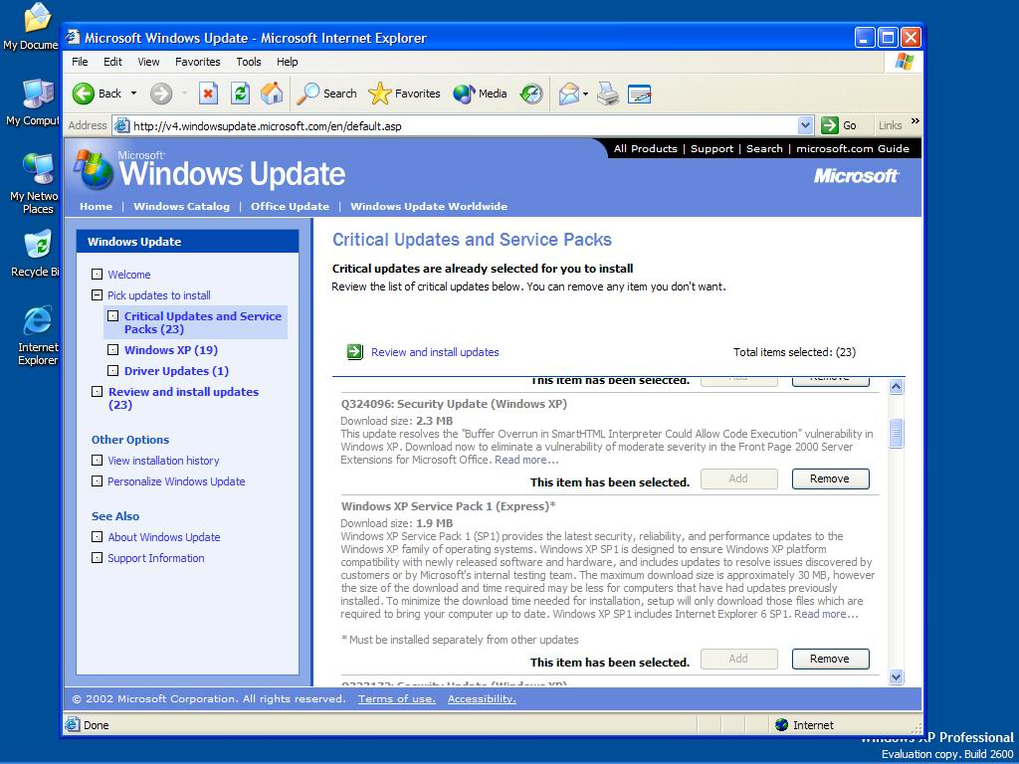

4.0 Driver Installation for Windows 2000

- Please make sure VIA USB 2.0 PCI adapter card has been installed on your system correctly. Open the Device Manager and check if there is a “Universal Serial Bus (USB) Controller” in “Other devices”.

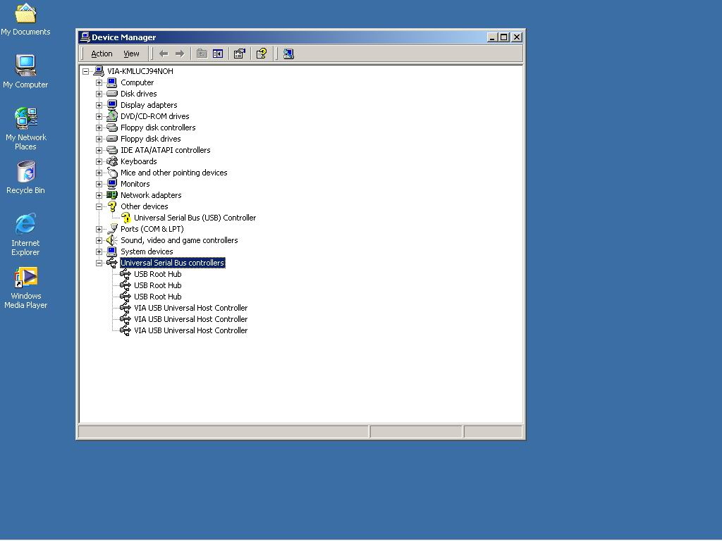
- Insert the supplied “Windows 98/ME/Win2K/WinXP USB 2.0 Driver Installation CD” and execute the setup program by double clicking on the “SETUP.exe” file.

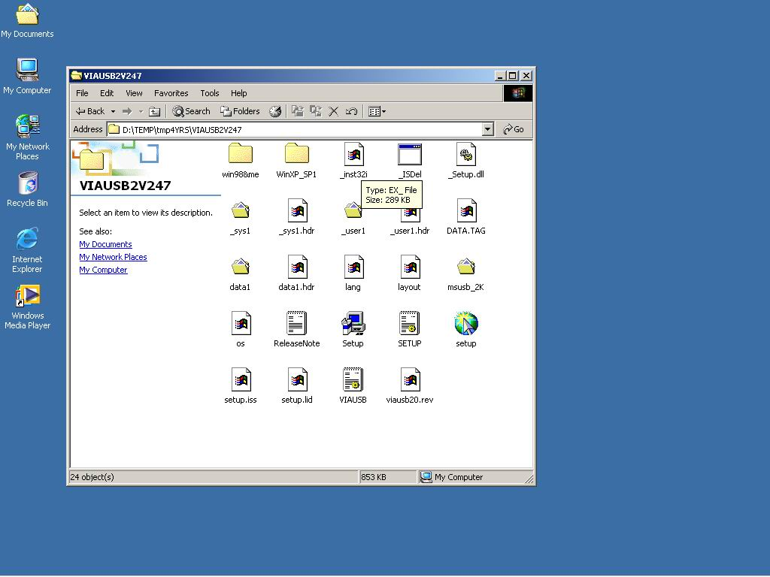
- It’s the Software License Agreement of VIA. Please read it FIRST and Press “Yes” if you want to stat the driver installation.

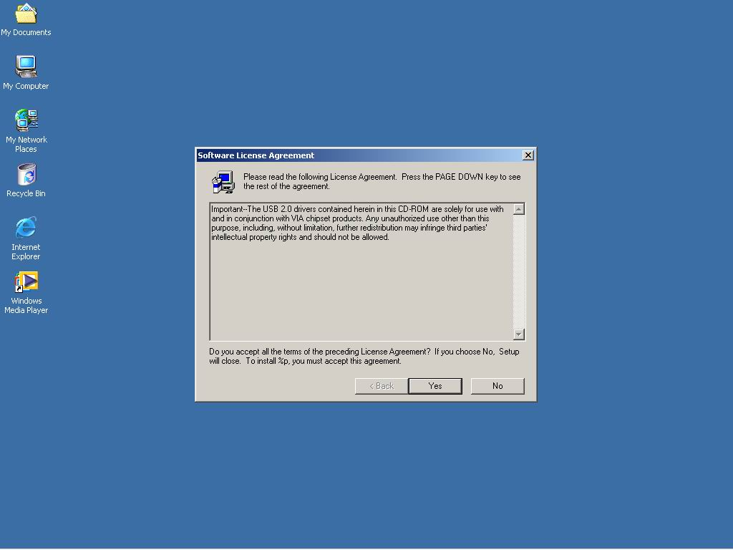
- Press “Next”.

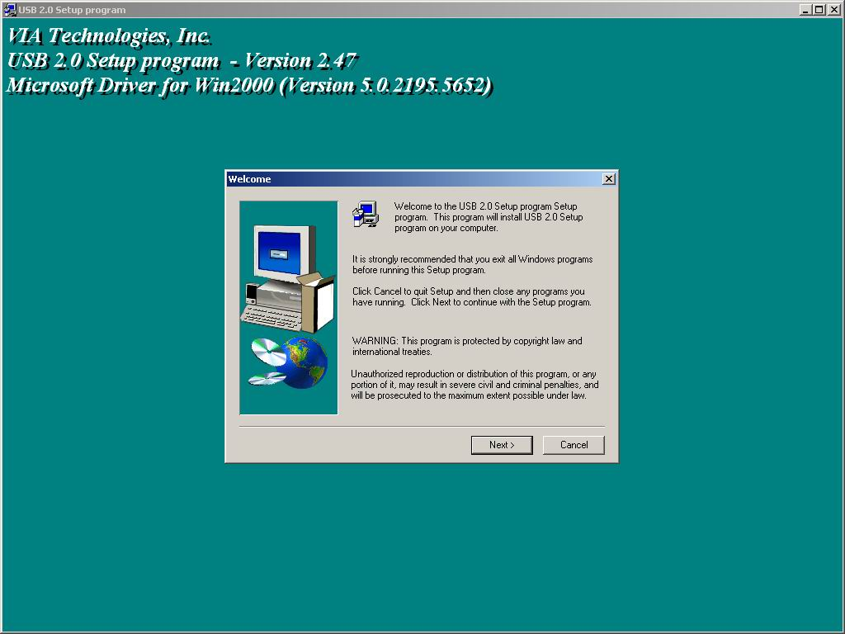
- Select “Install USB Driver” and press “Next”.

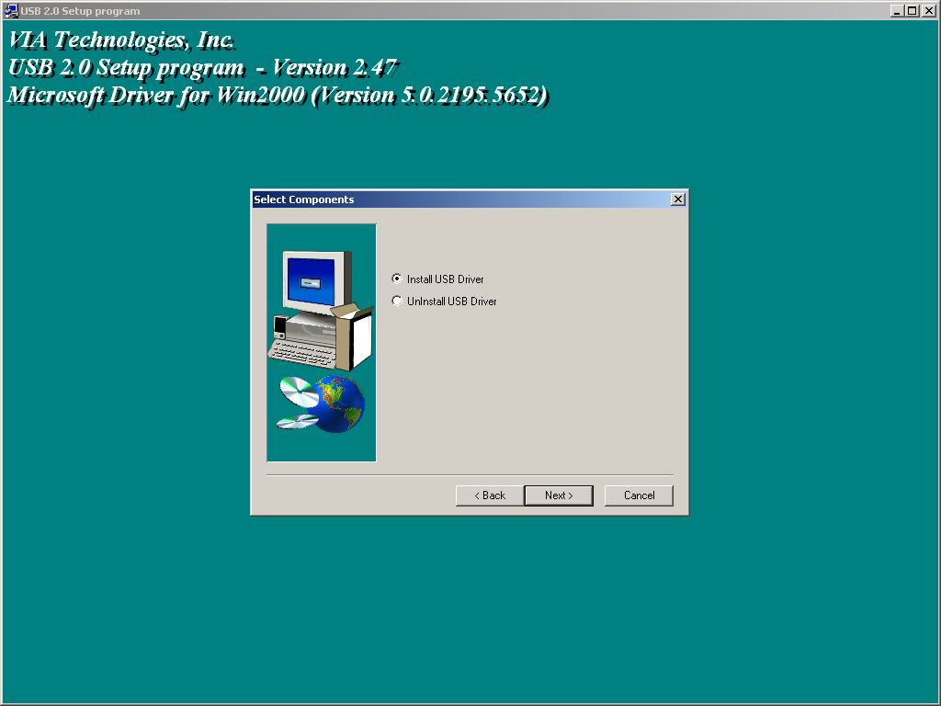
- It’s the Software License Agreement of Microsoft . Please read it FIRST and Press “Yes” if you want to continue the driver installation.

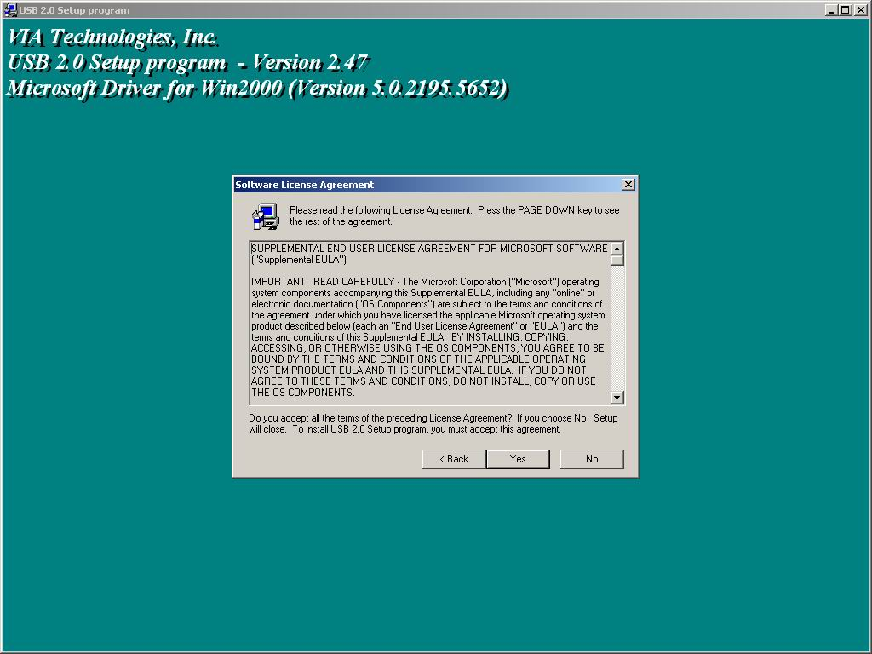
- Press “OK”

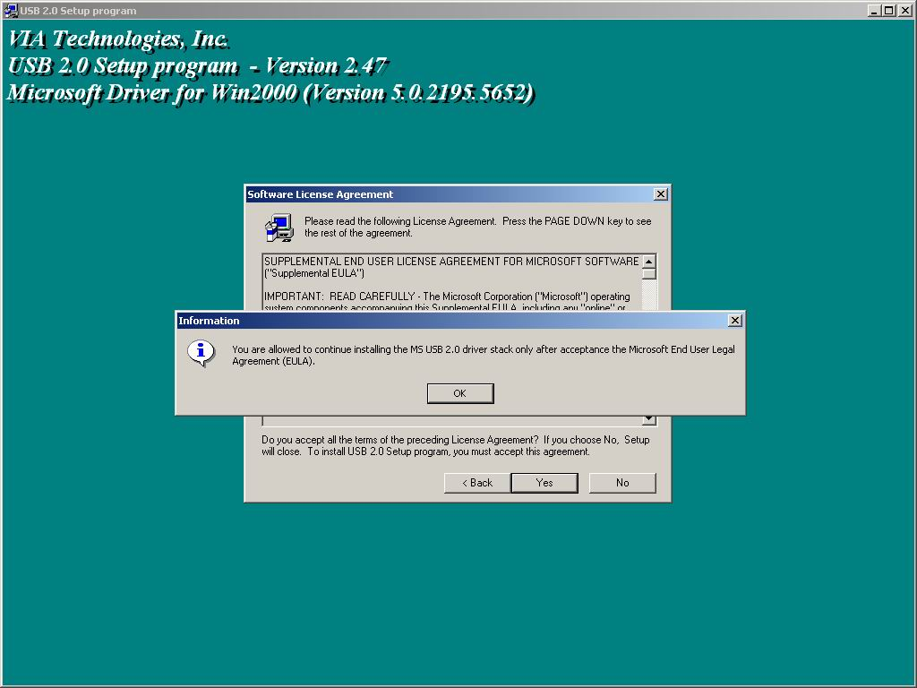
- Press “Print to File”

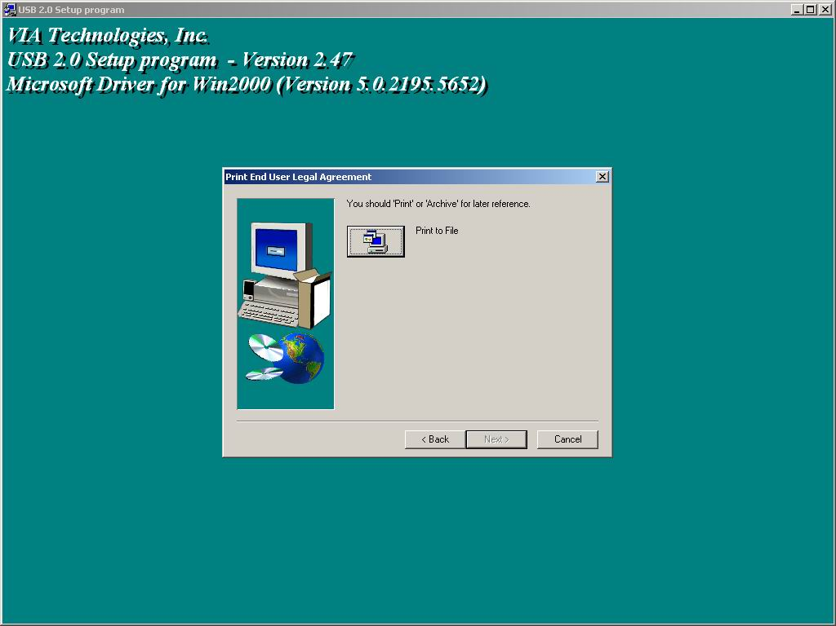
- Press “OK”

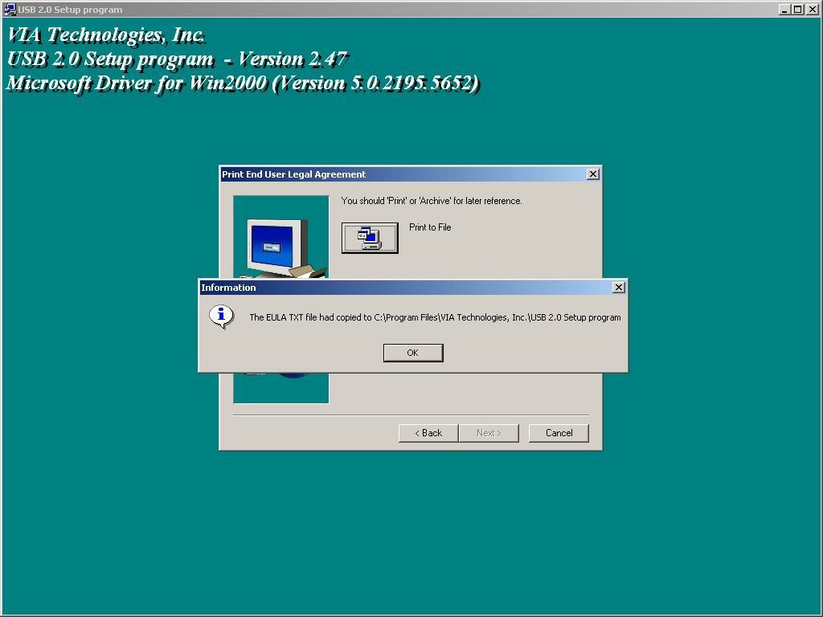
- Press “Finish”. Microsoft EHCI drivers for Windows 2000 are installed successfully. Welcome to the High-Speed USB 2.0 world.

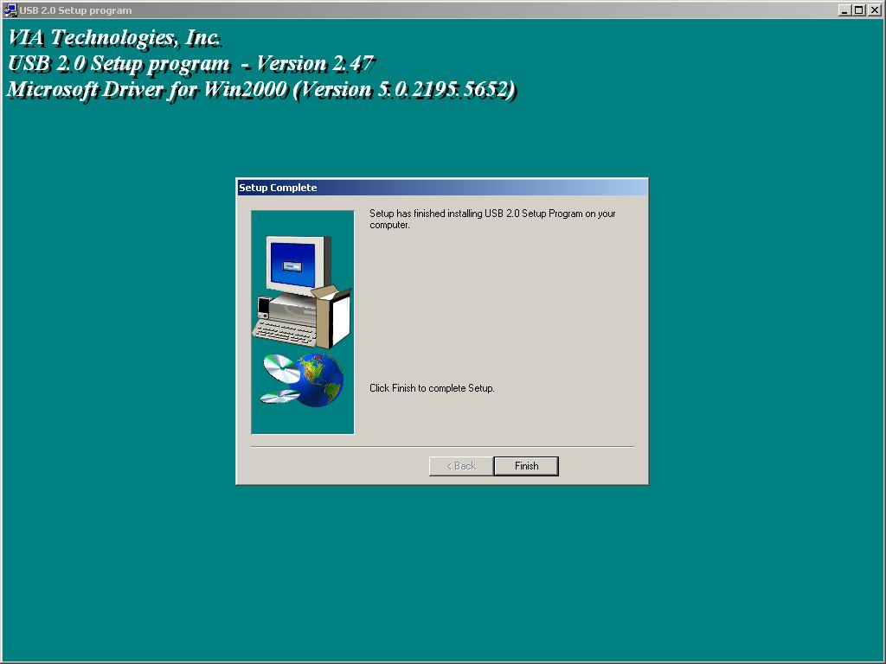
5.0 Driver Installation for Windows ME/98SE/98

- Please make sure VIA USB 2.0 PCI adapter card has been installed on your system correctly. Open the Device Manager and check if there is a yellow exclamation mark on one of the “VIA Tech 3038 PCI to USB Universal Host Controller” item.

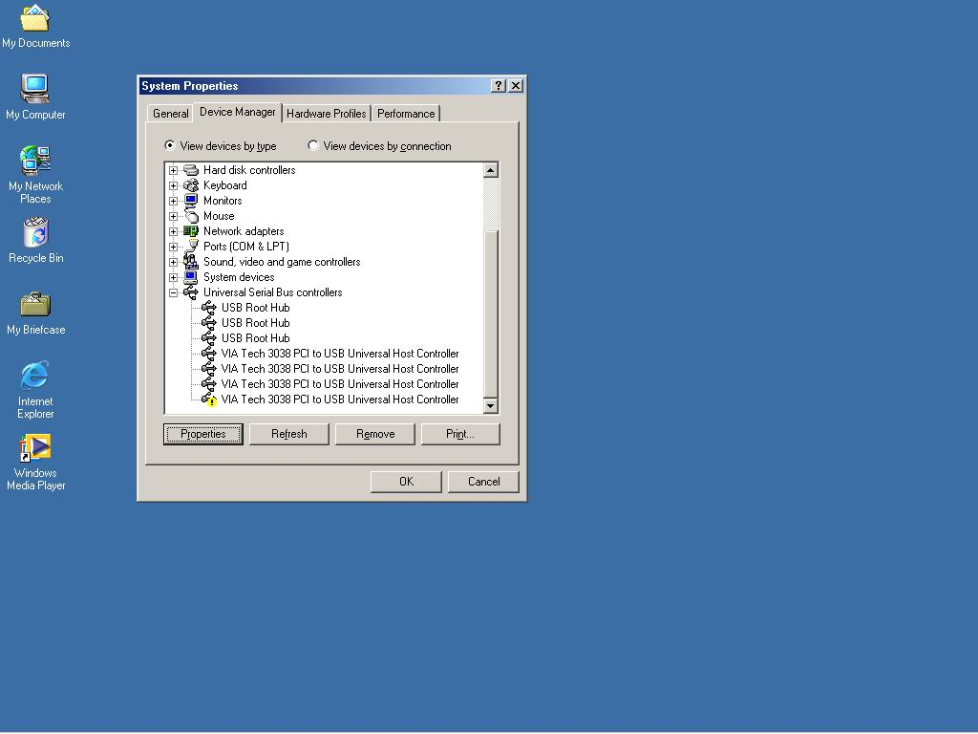
- Insert the supplied “Windows 98/ME/Win2K/WinXP USB 2.0 Driver Installation CD” and execute the setup program by double clicking on the “SETUP.exe” file.

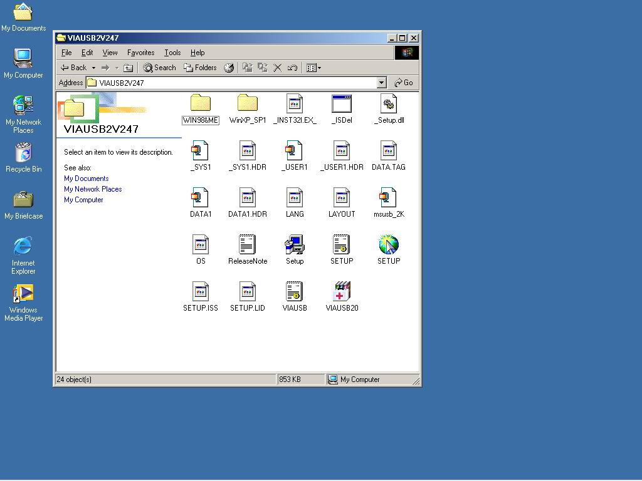
3. Press “Next”

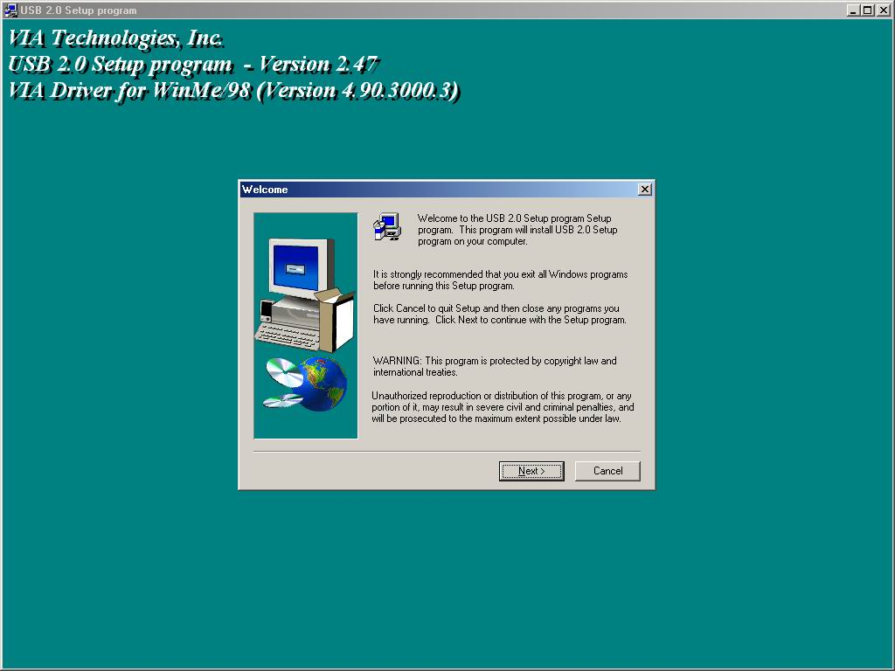
- Select “Install USB Driver” and press “Next”.

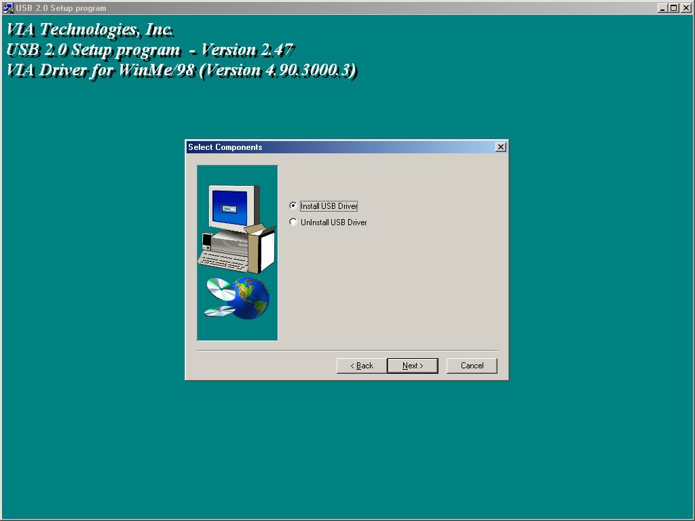
- Press “Finish”. This will RESTART your system. Please remember to SAVE your files before you click “Finish” button.

