___________________________________________________
IMPORTANT INFORMATION
for
RAGE FURY MAXX

64MB (dual 32MB) versions
___________________________________________________

RELEASE NOTES
March, 2000
___________________________________________________

READ THIS FILE COMPLETELY BEFORE USING THIS PRODUCT!
___________________________________________________

Contents
1.0 Introduction
2.0 System Requirements
3.0 Known issues with games
4.0 Known issues with some systems
- Other known problems
- Installation Notes for Notes For Accelerated Graphics Port (AGP) Systems
- Driver Installation Notes
- 3Deep Bundle
___________________________________________________

1.0 Introduction

This file contains last-minute updates that are not found in the User's
Guide or in any addendum accompanying this product.

This release includes:
- ATI Display Drivers version A6.32.0
- ATI DVD player version 3.2.0.1

The following components are also installed:
- DirectX 7.0a
- DX MEDIA 6.0

2.0 System Requirements
Minimum PC requirements for RAGE FURY MAXX
- Pentium II / Pentium III, AMD K6-3 / Athlon or compatible systems with AGP 2X or AGP2X/4X universal slot
- DVD drive and minimum Pentium II (266) (to play DVD discs)
- Windows 98 or Windows 98 SE
__________________________________________________

3.0 Known issues with games

Microsoft BASEBALL: FAILS TO LOAD

Please run the file located in x:\Install\R1289x\Atidrive\msbfix.reg (where x is your CD-ROM drive) before loading the game.

SIN: DOES NOT WORK IN FULL-SCREEN MODE

Download the latest patch from http://www.activision.com to resolve this issue.

FORCE 21: DISPLAY ANOMALIES

Run Force 21 DevicePicker and deselect “Use Antialiasing”

4.0 Known issues with some systems

FIC MOTHERBOARD WITH AMI SYSTEM BIOS REVISION NC606: SYSTEM DOESN’T BOOT. (NO POST)

AMI is currently investigating this issue and will address this issue with a new bios revision. Please visit FIC’s website for bios updates. (http://www.fic.com.tw/)

5.0 Other Known Problems
Because of its unique AFR (Alternate Frame Rendering) architecture Rage Fury Maxx exhibits flashing/flickering with some games. There are special programming considerations for the Rage Fury Maxx in order to enhance game experience and ATI is currently working with game developers to ensure AFR support for future games and a fix for current games with such behavior.

These problems appear with certain specific actions by the game applications. A typical problem area is reusing portions of a previous frame to generate the current scene. An example of when such a precaution is necessary is during a game’s ‘Loading’ splash-screen that displays a progress bar throughout a scene or level loading operation. If the background is static, it is typically drawn once into each rendering surface in the flipping chain at the start of the loading sequence. Only the progress bar is updated during subsequent frames until loading has completed. Applications that expect a single instance of each rendering surface, that is those that do not account for AFR, will only update half of the rendering surfaces in the dual flipping chains. This will result in visible flickering when surfaces with stale background data are displayed. The solution is to draw the background twice as many times as originally intended, that is, four times when double buffering and six times when triple buffering.

Another example is games that update part of the screen infrequently, for example games with cockpits, dashboards, or game status information. Such games should ensure that these partial screens are updated for all applicable surfaces in the dual flipping chains.

In the meantime, disabling dual-chip mode under MAXX settings will resolve issues with such games.
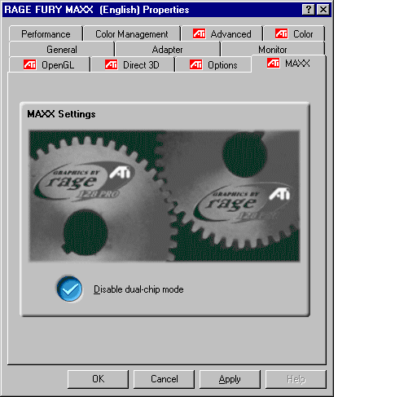

Multi-Monitor Support.
As Rage Fury Maxx is focused for the avid gamer, and multi-monitor isn’t a widespread gaming feature, this feature isn’t supported for this driver set.

6.0 Installation Notes For Accelerated Graphics Port (AGP) Systems

FOR SYSTEMS USING INTEL CHIPSETS

In addition to ATI enhanced display, your system may require installation of the most recent AGP services VxD (virtual device driver).

For Windows you may require an updated VGARTD.VxD to support newer Intel chipsets. Your system vendor should have included the appropriate GART file as part of you Windows install image. However, if you experience display problems following installation, you should obtain the latest Virtual GART (AGP) Driver from the motherboard manufacturer. If you cannot locate the motherboard manufacturer, generic VxD drivers can usually be obtained from the Intel web site. http://developer.intel.com/design/chipsets/

FOR SYSTEMS USING NON-INTEL CHIPSETS

Several AGP motherboard manufacturers use non-Intel AGP chipsets. Chipsets include those made by Acer Laboratories (ALI), Silicon Integrated Systems (SIS), and VIA Technologies, Inc. Each non-Intel chipset requires the installation of a custom Virtual GART Driver. It is very important that the correct VxD driver be installed before operating your system. An incorrect or missing GART can cause a black screen after Windows loads.

In most cases, for those chipset manufacturers just mentioned, the system vendor will have included the appropriate GART file as part of you Windows install image. However, if you experience display problems following installation, you should obtain the latest Virtual GART (AGP) Driver from the motherboard manufacturer. If you cannot locate the motherboard manufacturer, generic VxD drivers can usually be obtained from the chipset manufacturer.
Please refer to one of the following websites:

Motherboard/chipset information at http://www.motherboards.org
Acer Laboratories (ALI) at http://www.ali.com.tw/eng/support/driver.shtml
Silicon Integrated Systems (SIS) at http://www.sis.com.tw/driver/driver.htm
VIA Technologies at http://www.via.com.tw/drivers/index.htm

GARTS PROVIDED ON THE CD

ATI has provided, on this CD, the most current and common GART files that were available at the time of release. They are located on the ATI CD under the subdirectory \INSTALL\GART.

The GART files may be out of date and newer ones may be found at manufacturers web site.

7.0 Driver Installation Notes

If you are upgrading from a non-released CD, please remove current drivers before installing latest drivers.

8.0 3Deep Bundle

3Deep, produced by Ecolor, is provided to ensure your system displays accurate lighting and shading (gamma Values) enabling vibrant realism and awesome texture for today's PC games. The ‘Set Game Gamma’ button improves all gaming environments, and many leading DirectX games leverage 3Deep to automatically optimize your lighting and shading. The days of monitor tweaking and washed out images are over.
"See first, shoot first" advantage for on-line gamers.

True Internet Color is provided separately by Ecolor. Please visit www.ecolor.com for more details on 3Deep.

